# Module-4 Database

1. What is RDBMS

* RDBMS stands for Relational Database Management System. RDBMS is a program used to maintain a relational database. RDBMS is the basis for all modern database systems such as MySQL, Microsoft SQL Server, Oracle, and Microsoft Access.

1. What is SQL

* SQL stands for Structured Query language. SQL is the standard language for dealing with Relational Databases. SQL can be used to insert, search, update, and delete database records. SQL can do lots of other operations, including optimizing and maintenance of databases.

1. Write SQL Commands

* DDL – Data Definition Language DML – Data Manipulation Language DCL – Data Control Language DQL – Data Query Language

1. What is join?

* JOIN clause is used to combine the records from two or more tables in a database.

1. Write type of joins.

* INNER JOIN
* LEFT JOIN
* RIGHT JOIN
* FULL JOIN

1. How Many constraint and describes it self

* NOT NULL – Ensures a column cannot have NULL values.
* UNIQUE – Ensures all values in a column are unique.
* PRIMARY KEY – A combination of NOT NULL and UNIQUE; uniquely identifies records.
* FOREIGN KEY – Ensures data integrity between two tables.
* CHECK – Enforces a specific condition or rule on the data.
* DEFAULT – Assigns a default value to a column when no value is specified.
* INDEX – Optimizes query performance and can enforce uniqueness (through a unique index).

1. Difference between RDBMS vs DBMS

* DBMS
* DBMS does not support client-server architecture. RDBMS supports client-server architecture.
* DBMS has low software and hardware requirements.
* DBMS stores data as a file.
* DBMS supports single user.
* In DBMS, data redundancy is common
* RDBMS
* RDBMS has higher hardware and software requirements. In DBMS, data redundancy is common
* In RDBMS, key and indexes do not allow data redundancy.
* RDBMS supports client-server architecture.
* RDBMS supports multiple users.
* RDBMS is stored in the form of tables.

1. What is an SQL alias?

* A responsive web design involves creating a flexible web page that is accessible from any device, starting from a mobile phone to a tablet. Furthermore, a responsive web design improves users’ browsing experience.

1. Write a query to create the table in Structured Query Language.

* Create Table sellers

(id int (11) primary key Auto_increment ,

Name varchar (255),

Contact bigint (11),

Address varchar (255),

Email varchar(255),

Password varchar (255),\

);

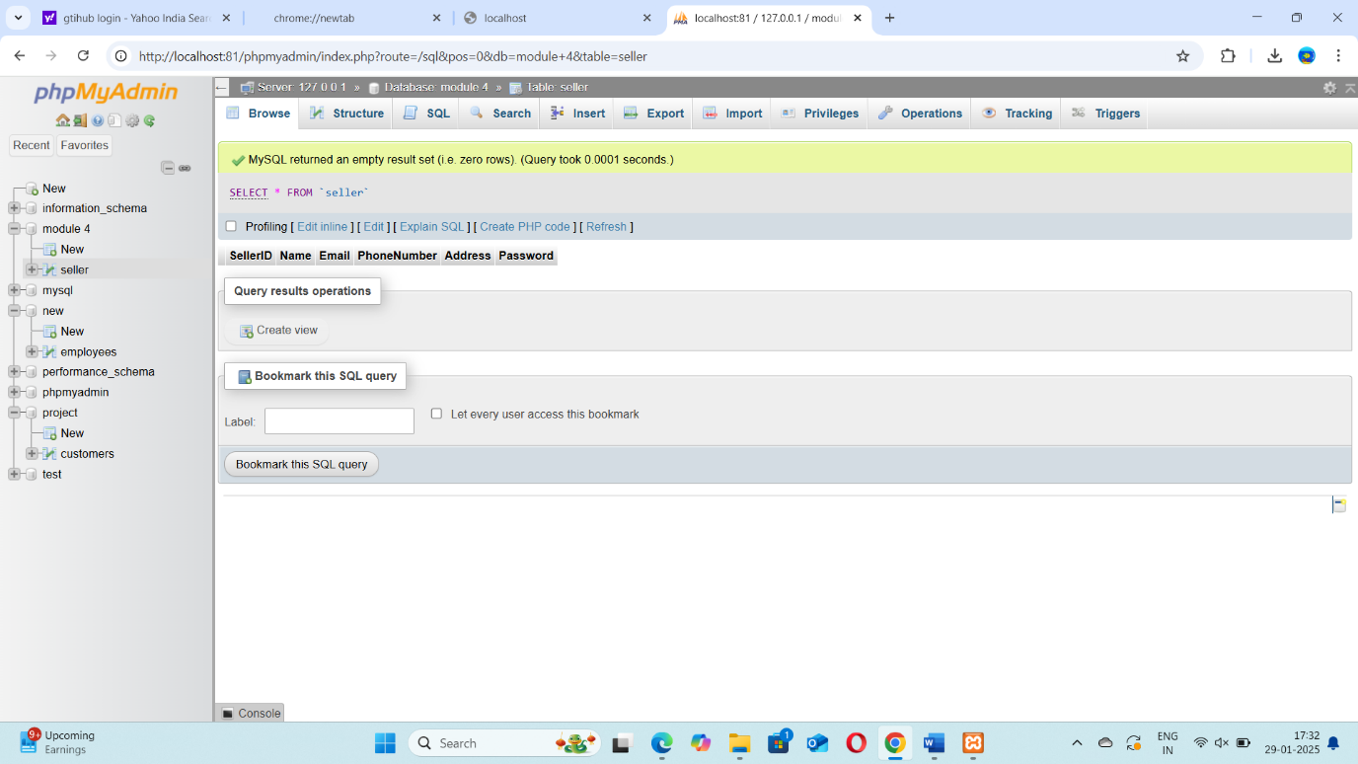

1. Write a query to insert data into table

* Insert INTO Seller (SellerID, Name, Email, PhoneNumber, Address, Password)

VALUES (’sakshi’,’ssaskshipatel580@gmial.com’,9265239078,’Ahmedabad’,23022242’),

(’Sanvi’,’sanvipatel21@gmail.com’,96240663443,’Ahmedabad’,’Sanvi@wen’),

(‘Hetal’,’Hetaljadav45@gmail.com’,9033178002,’Nadiad’,’Heta567’);

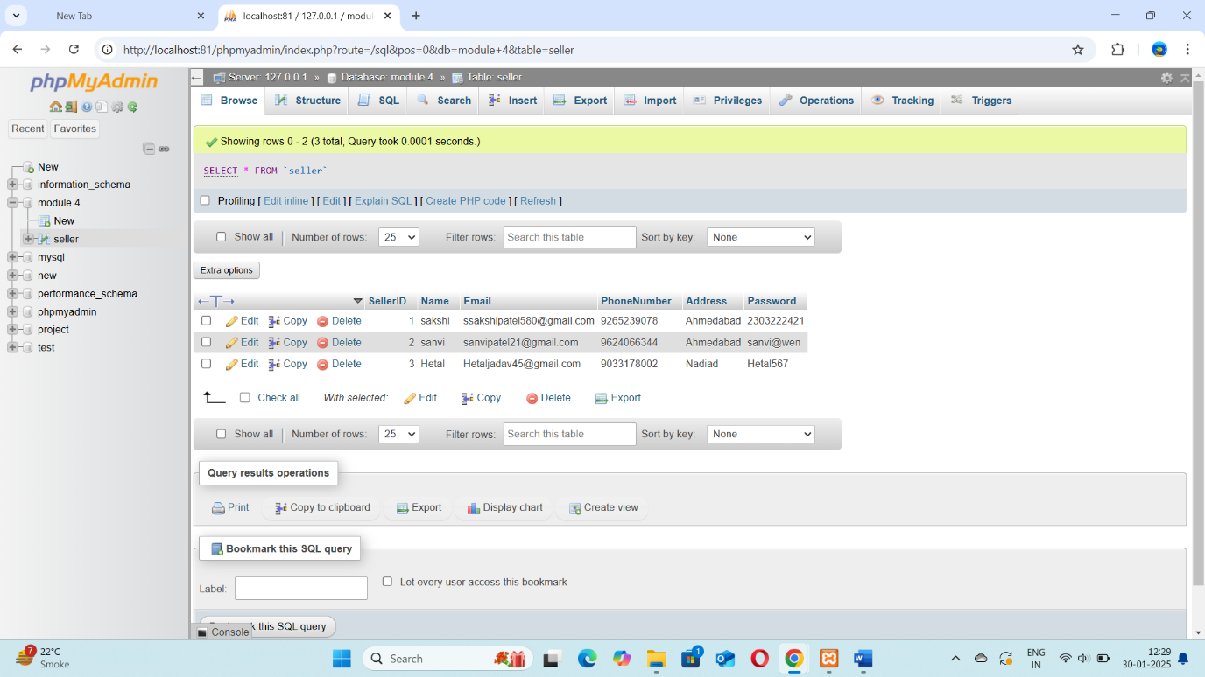

1. Write a query to delete data from table with validations

* DELETE FROM seller WHERE SellerID = 1;

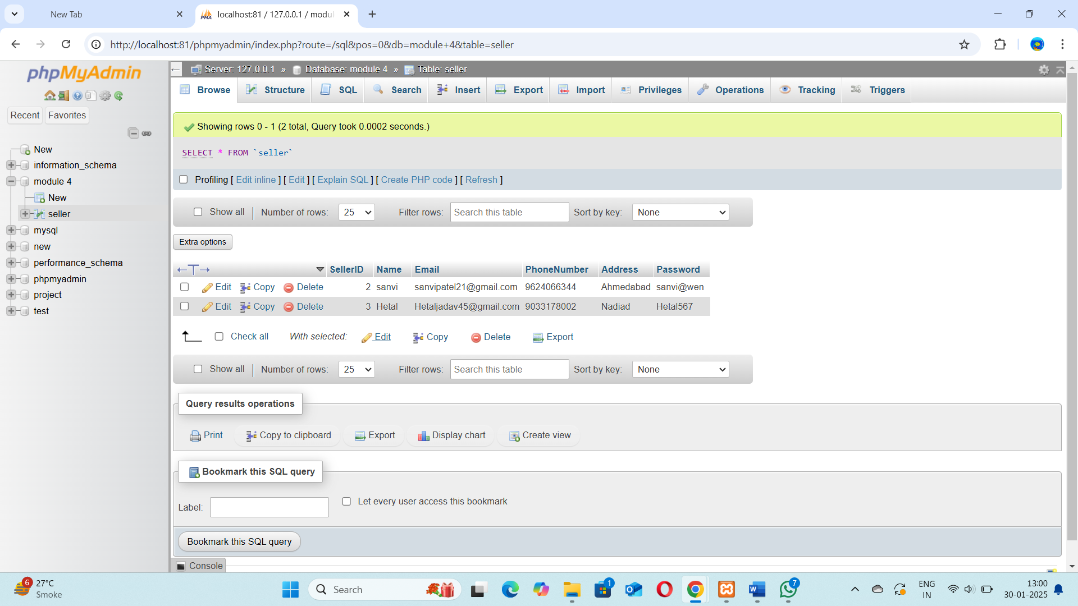

1. Write a query to insert new column in existing table.

* ALTER TABLE Seller add column DOB Date;
* ALTER TABLE Seller add column salary int;

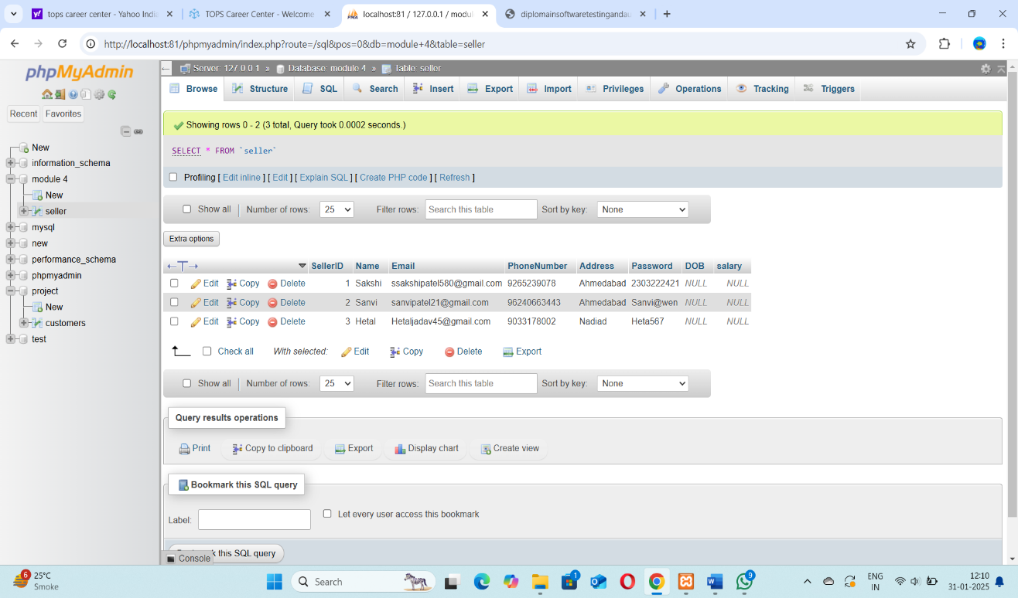

1. Write a query to drop table and database.
2. Write a query to find max and min value from table.

* SELECT MAX(salary) AS max_value, MIN(salary) AS lowest_value

FROM seller ;

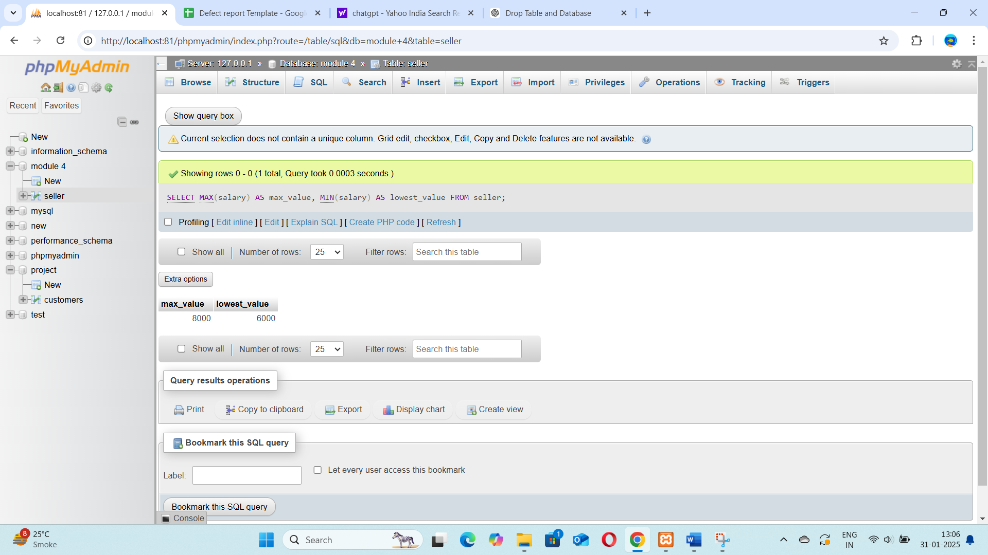

1. Write a query to update data into table with validations.

* UPDATE `seller` SET `Phone Number`= 9736512905 WHERE sellerid = 1;

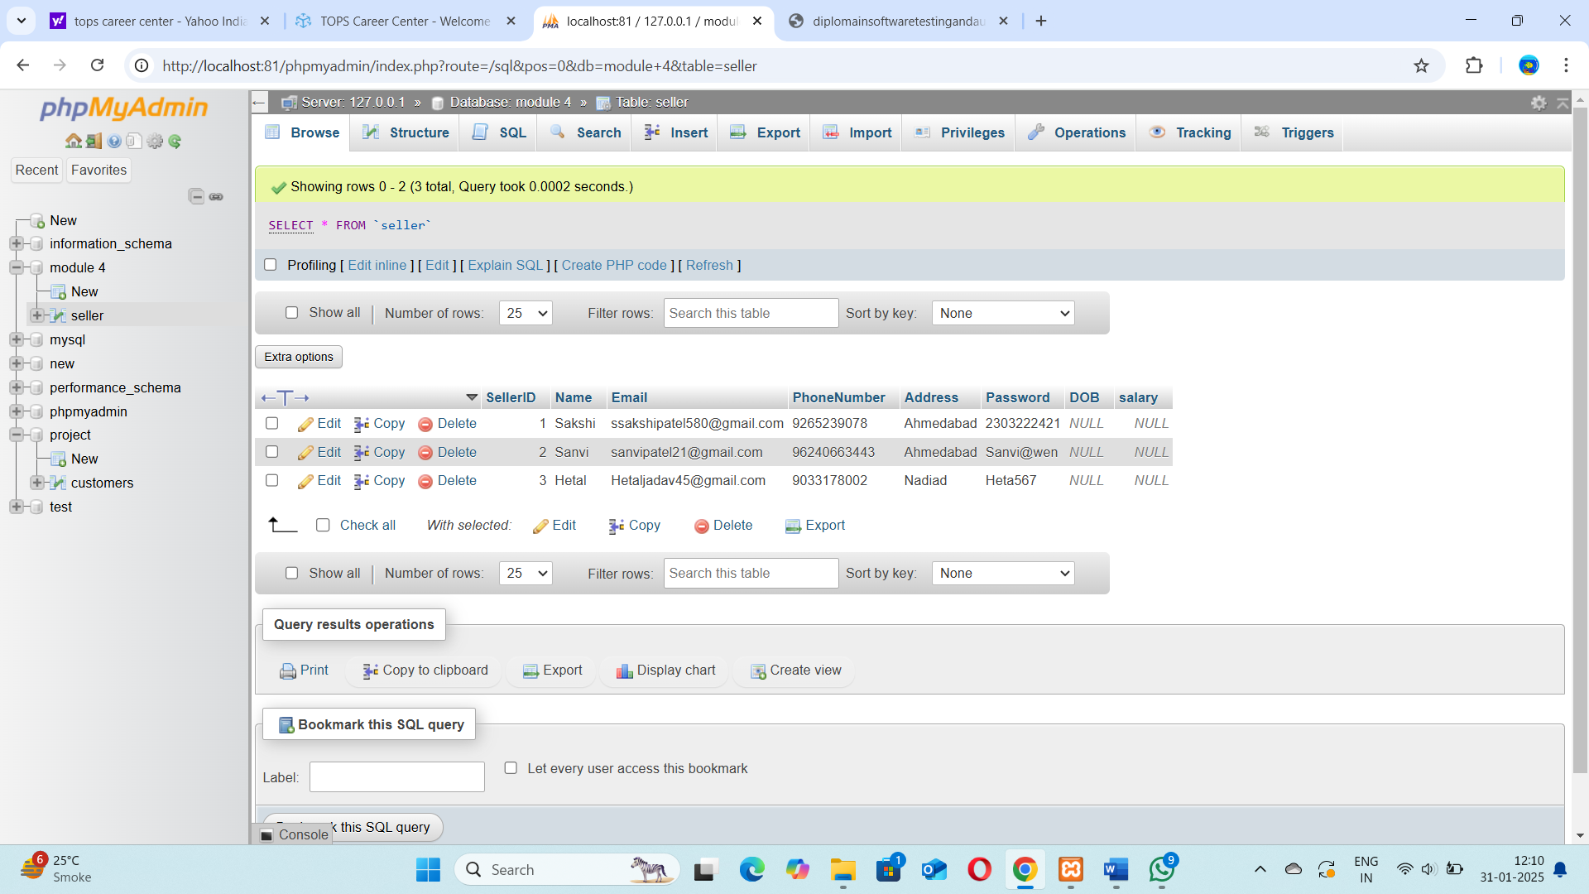

1. Create two tables named Seller and Product apply foreign key in product table Fetch data from both table using different joins.

* CREATE TABLE PRODUCT:

CREATE TABLE Product (

product_id INT PRIMARY KEY AUTO_INCREMENT,

product_name VARCHAR(100),

price DECIMAL(10, 2),

sellerID INT,

FOREIGN KEY (sellerID) REFERENCES Seller(sellerID)

);

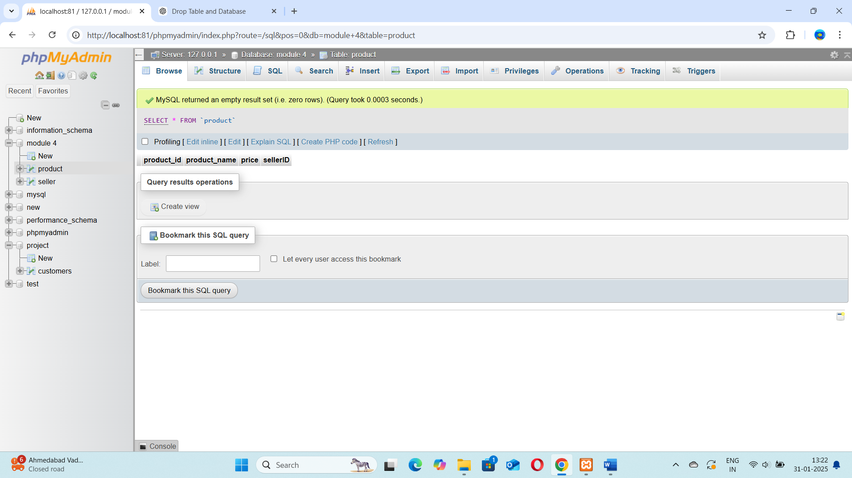

* INSERT INTO PRODUCT:

INSERT INTO Product (product_id, product_name, price, sellerID)

VALUES

(1, 'Laptop', 1200.00, 1),

(2, 'Smartphone', 800.00, 2),

(3, 'Tablet', 600.00, 1),

(4, 'Headphones', 150.00, 3);

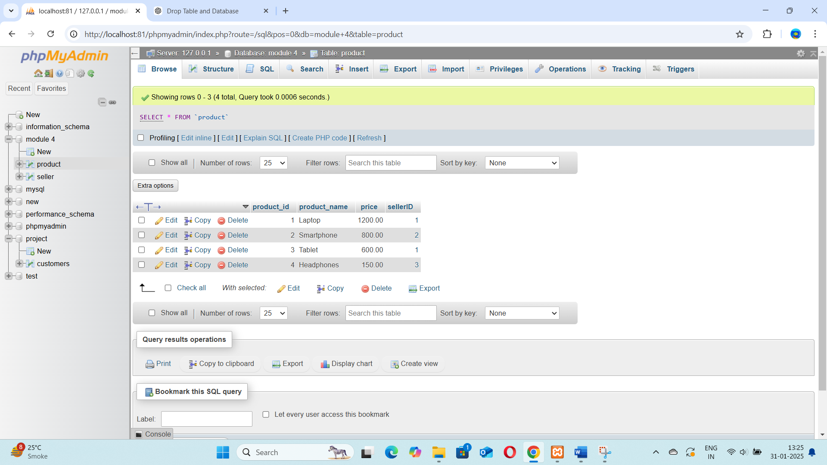

* Fetch Data Using Different Joins:

1. Inner join :

SELECT

product.product_name,

product.price,

seller.Name

FROM

product

INNER JOIN

seller

ON

product.sellerID = seller.SellerID;

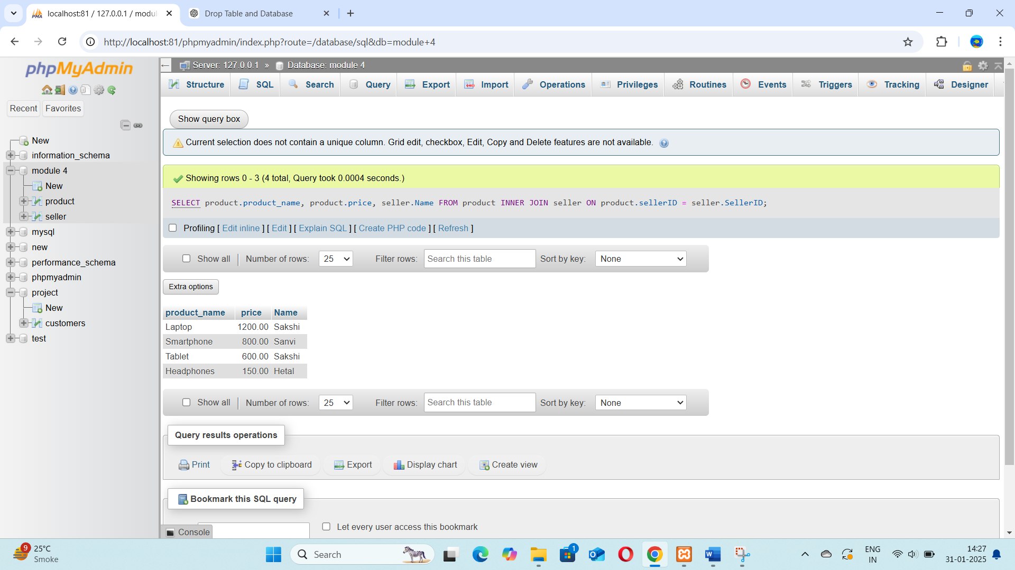

* Left join

SELECT

Product.product_id,

Product.product_name,

Product.price,

Seller.sellerID

FROM

Product

LEFT JOIN

Seller

ON

Product.sellerID = Seller.sellerID;

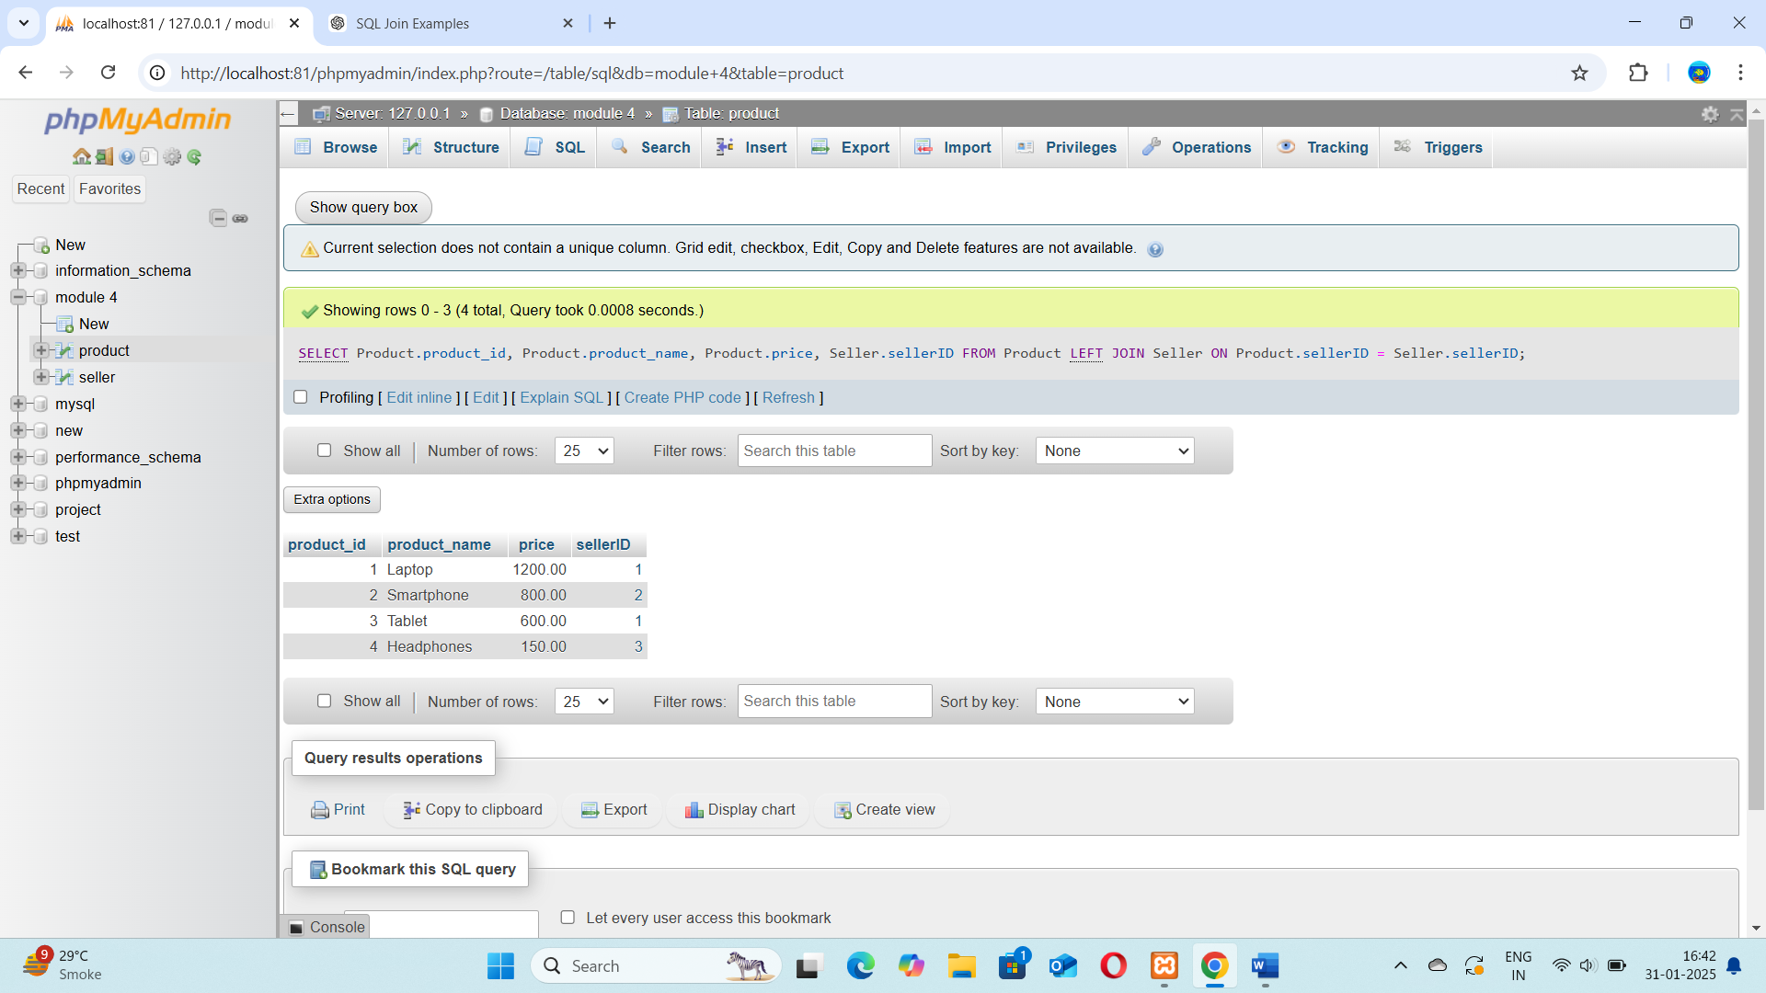

Right join :

SELECT

Product.product_id,

Product.product_name,

Product.price,

Seller.sellerID

FROM

Product

RIGHT JOIN

Seller

ON

Product.sellerID = Seller.sellerID;

1. What is API Testing

* Application Programming Interface (API) is a software interface that allows two applications to interact with each other without any user intervention.
* API (Application Programming Interface) is a computing interface which enables communication and data exchange between two separate software systems.

1. Types of API Testing

* There are mainly 3 types of API Testing.
* Open APIs
* Partner APIs
* Internal APIs

1. What is Responsive Testing?

* A responsive web design involves creating a flexible web page that is accessible from any device, starting from a mobile phone to a tablet. Furthermore, a responsive web design improves users’ browsing experience.

1. Which types of tools are available for Responsive Testing

* LT Browser
* Lembda Testing
* Google Resizer
* I am responsive
* Pixel tuner

1. What is the full form of .ipa, .apk

* IPA: International Phonetic Alphabet.
* APK: Android Application Package.

1. How to create step for to open the developer option mode ON?

* Step 1: Open mobile setting.
* Step 2: Go to About phone option and click on.
* Step 3: Go to Software information option and click on
* Step 4: Go to Build number option and click multiple time.
* Step 5: then show the message on display “developer option enabled